JForum2 Developer Quick-Start Guide v2.0
Import Source Code from SVN into Eclipse and Build with Maven
Andowson Chang, 2017/9/16

Environment:
OS:Windows 10 64-bit
JDK: Oracle Java SE JDK 8.0 Update 144 x64
IDE: Eclipse IDE for Java EE Developers 64-bit(eclipse-jee-oxygen-R-win32-x86_64.zip)

Install Subclipse
https://dl.bintray.com/subclipse/releases/subclipse/latest/
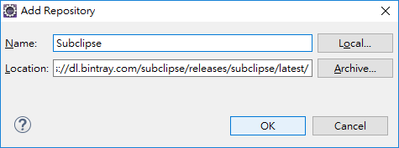
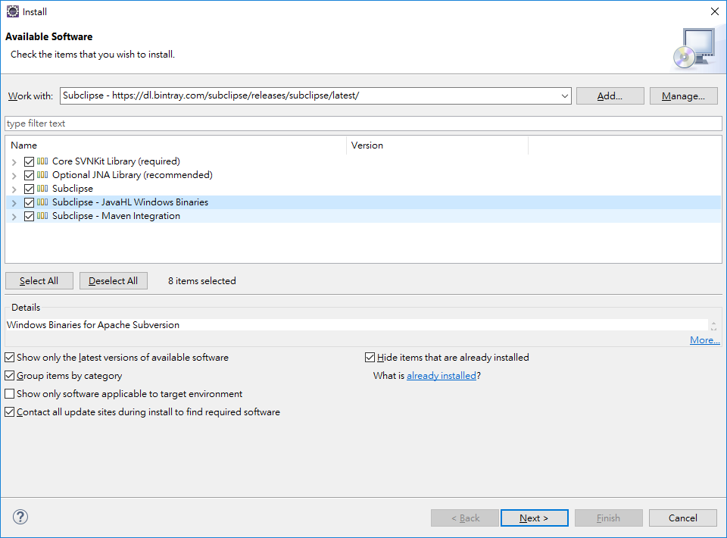
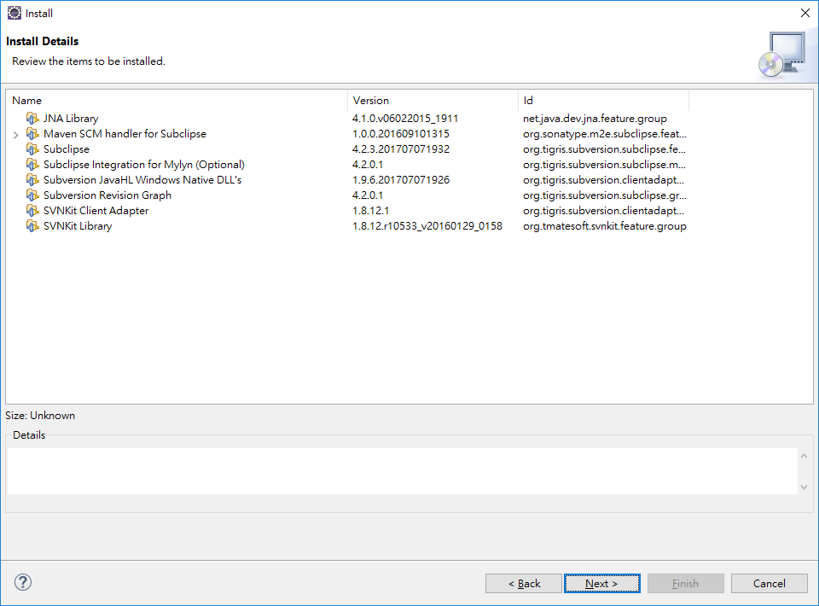
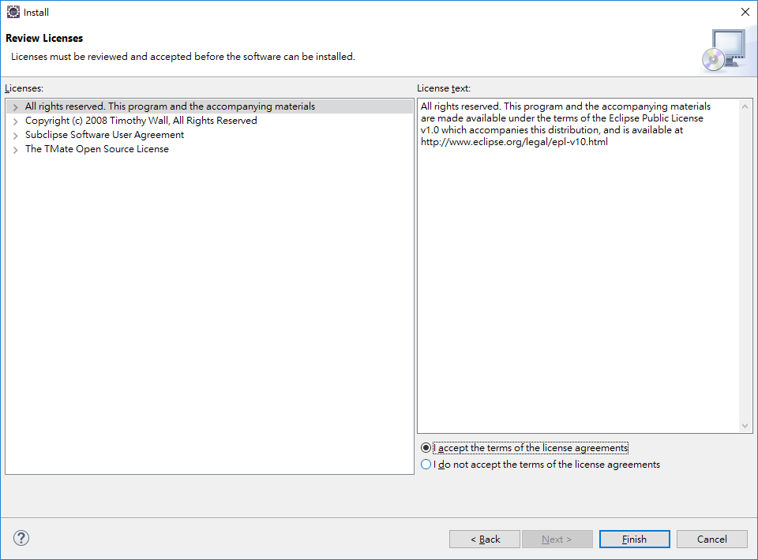
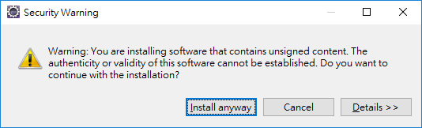
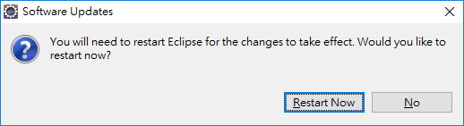
Modify Installed JREs
Windows > Preferences > Installed JREs
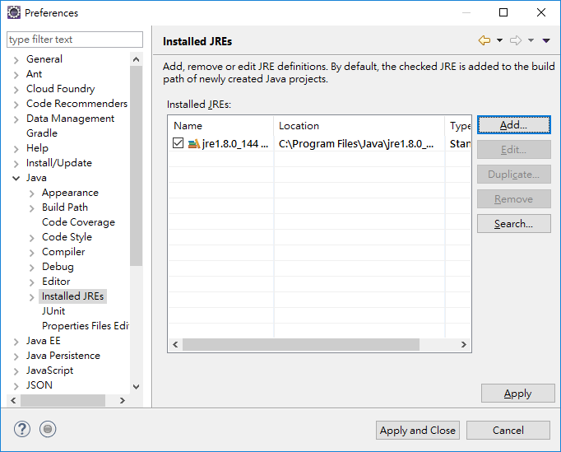
Add…
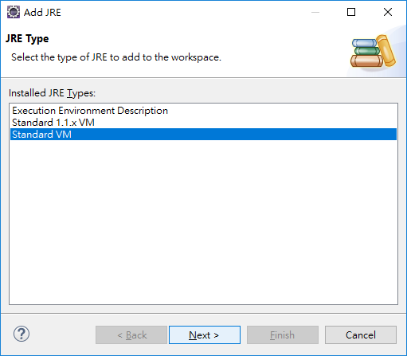
Next
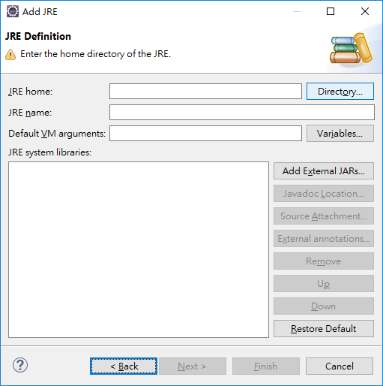
Directory…
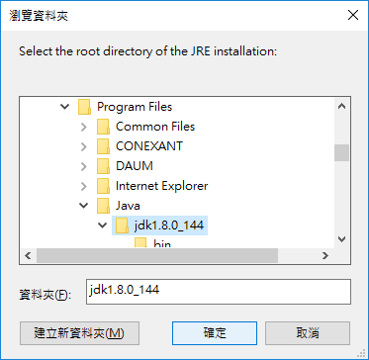
Choose the jdk directory

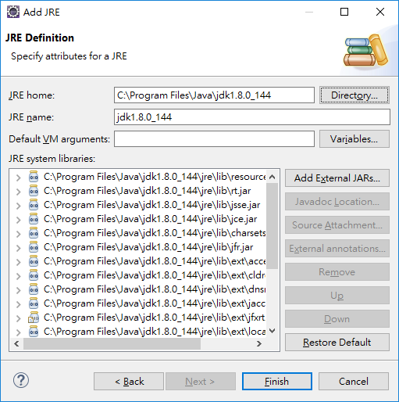
Windows > Preferences > Installed JREs

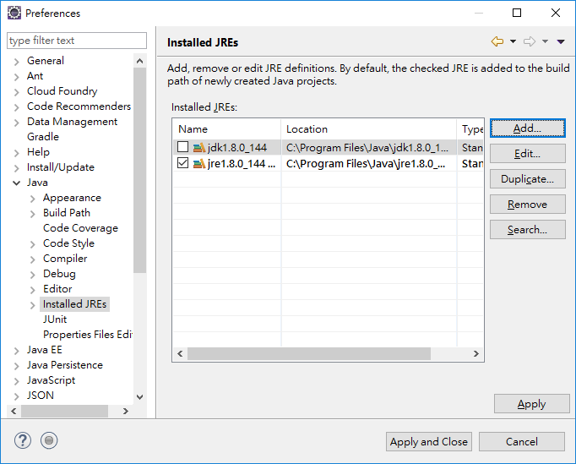

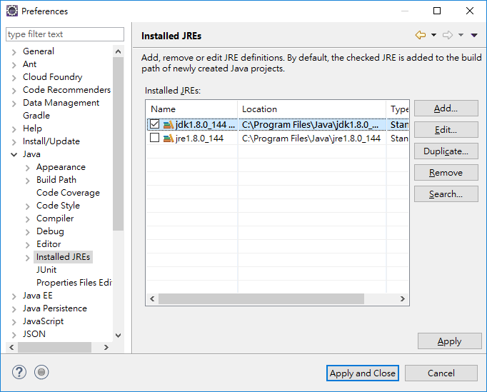

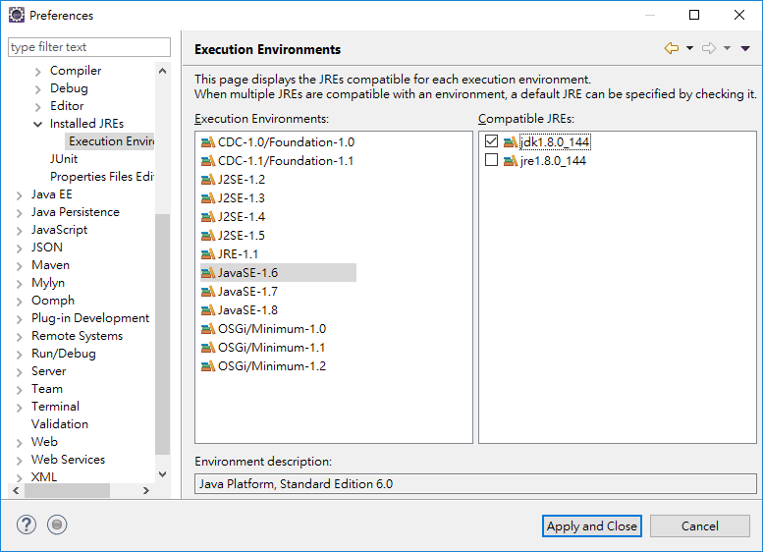
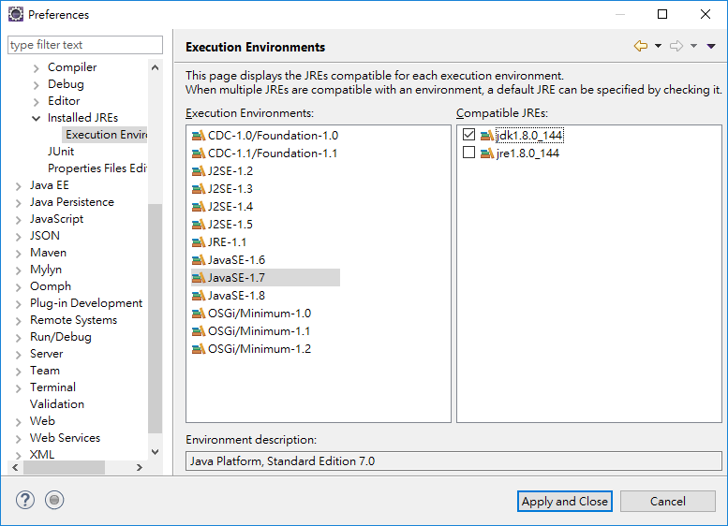
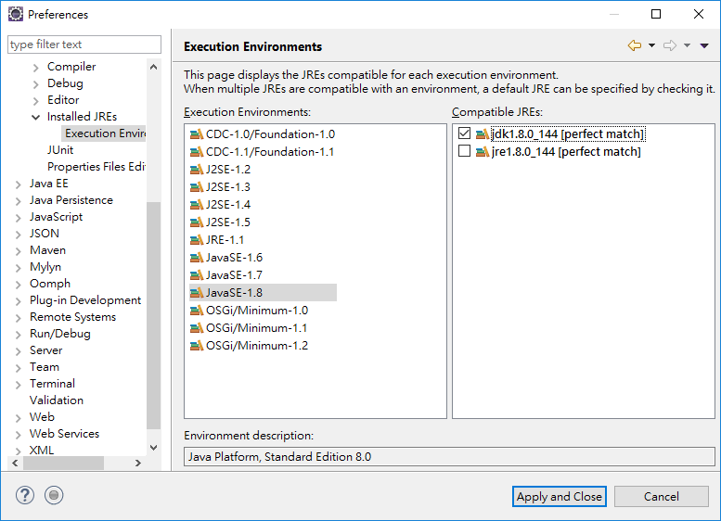

Import source code from SVN into Eclipse
File > Import …

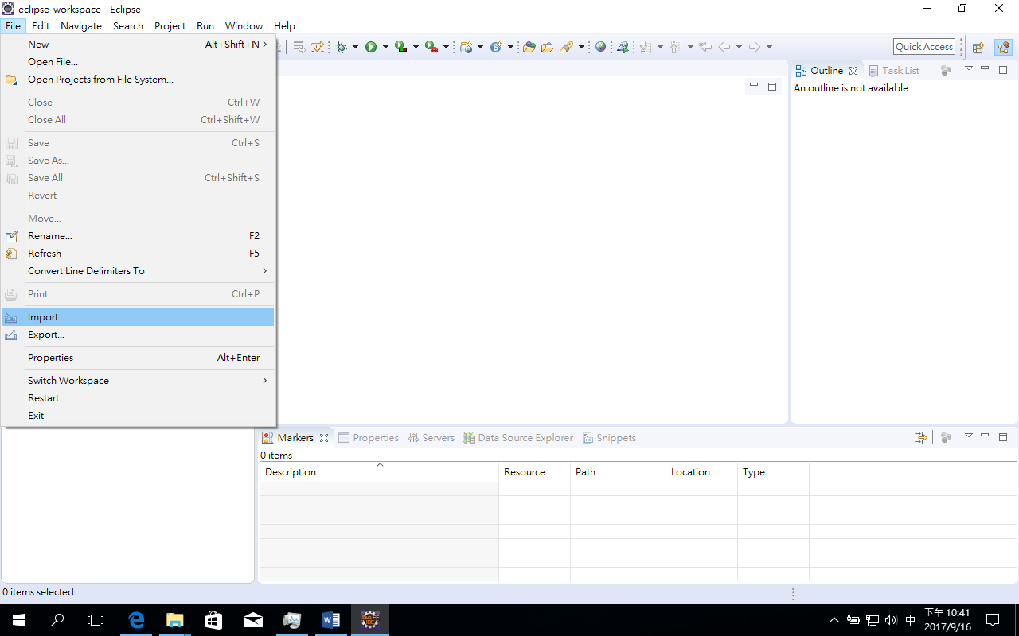
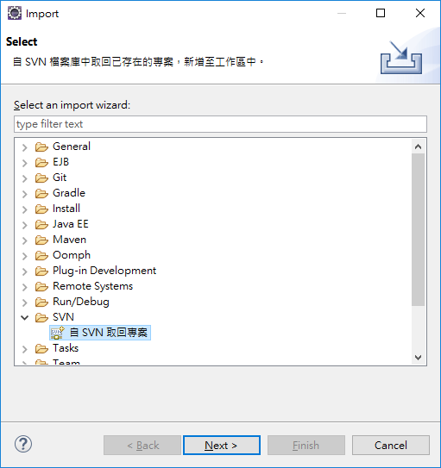

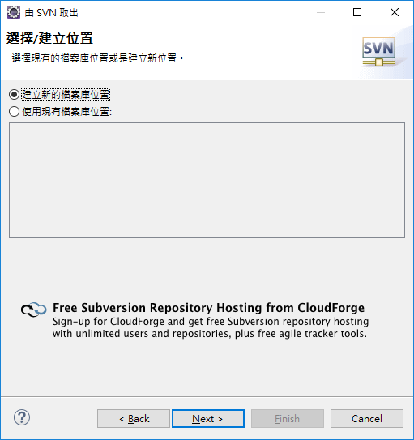

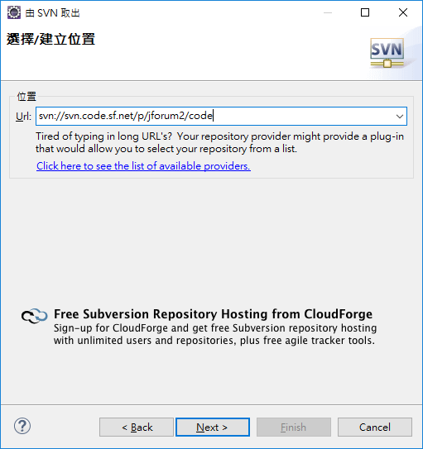
URL: svn://svn.code.sf.net/p/jforum2/code
Ignore the error message, just click on the OK button.
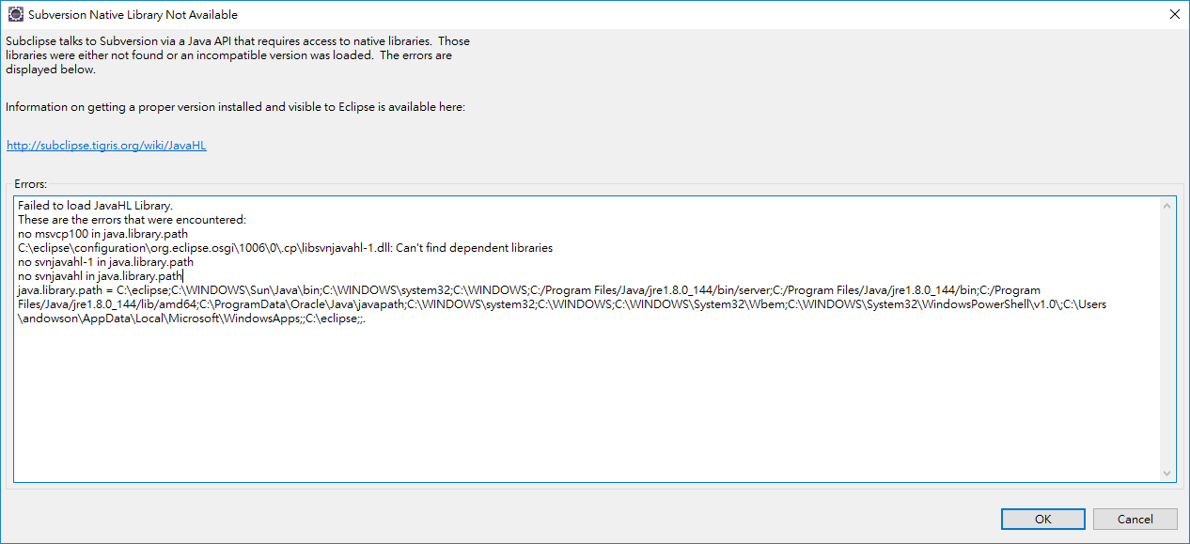

Expand trunk
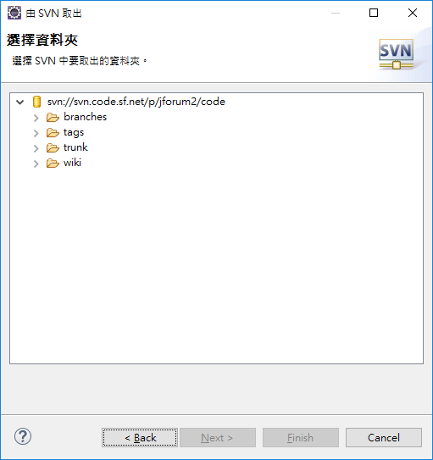
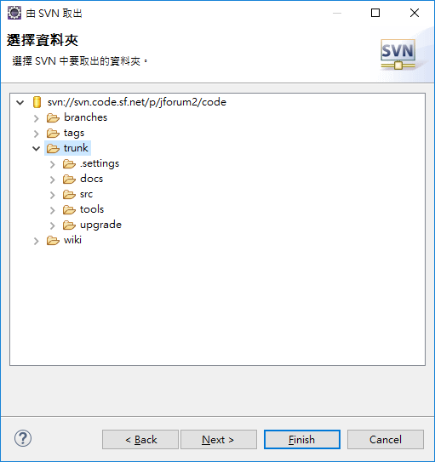

Select trunk and click Next
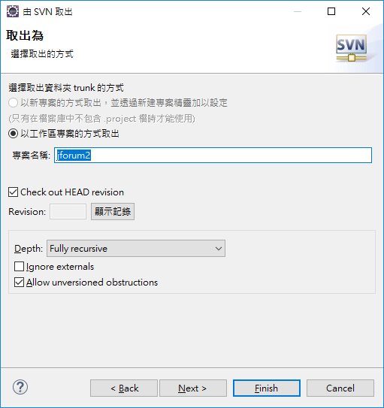

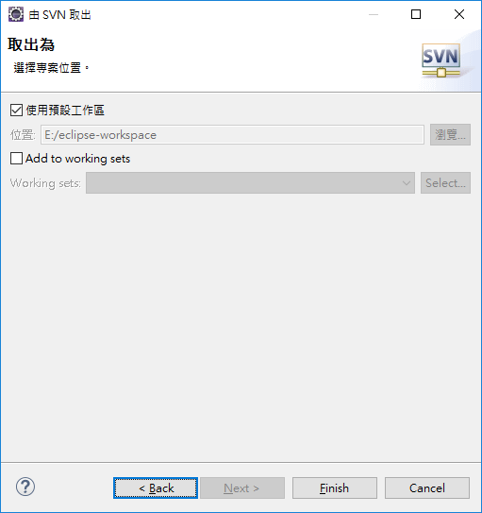
Checking out source code from SVN
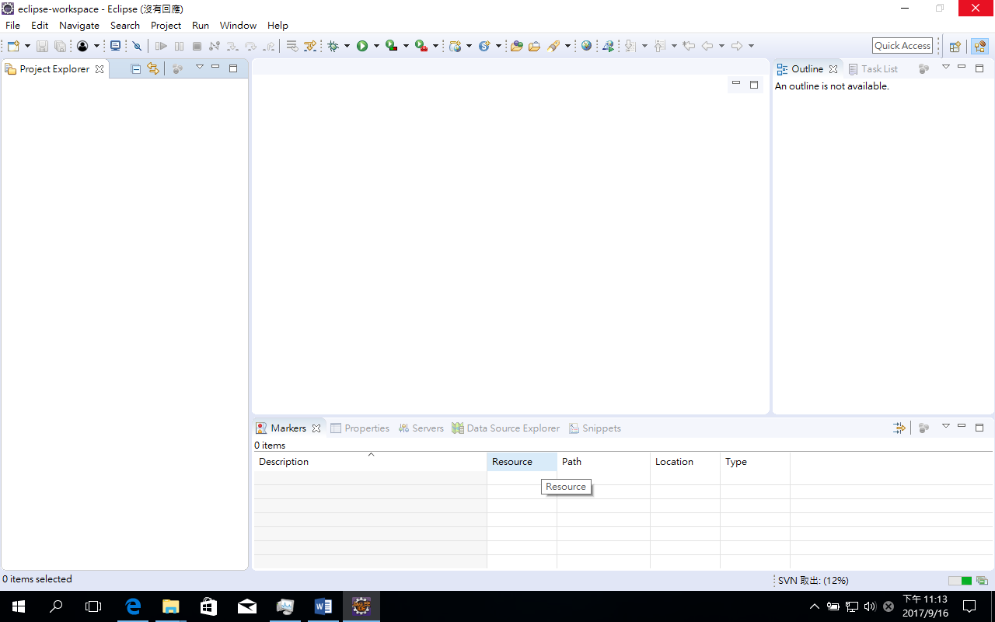
Switch to the Progress view
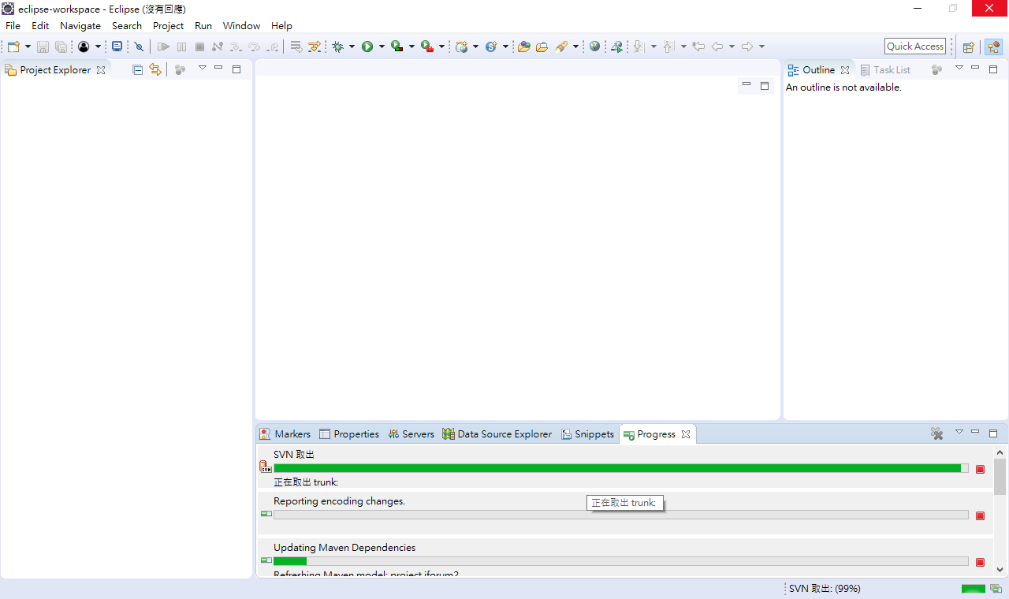
Now, we have downloaded the source code successfully.
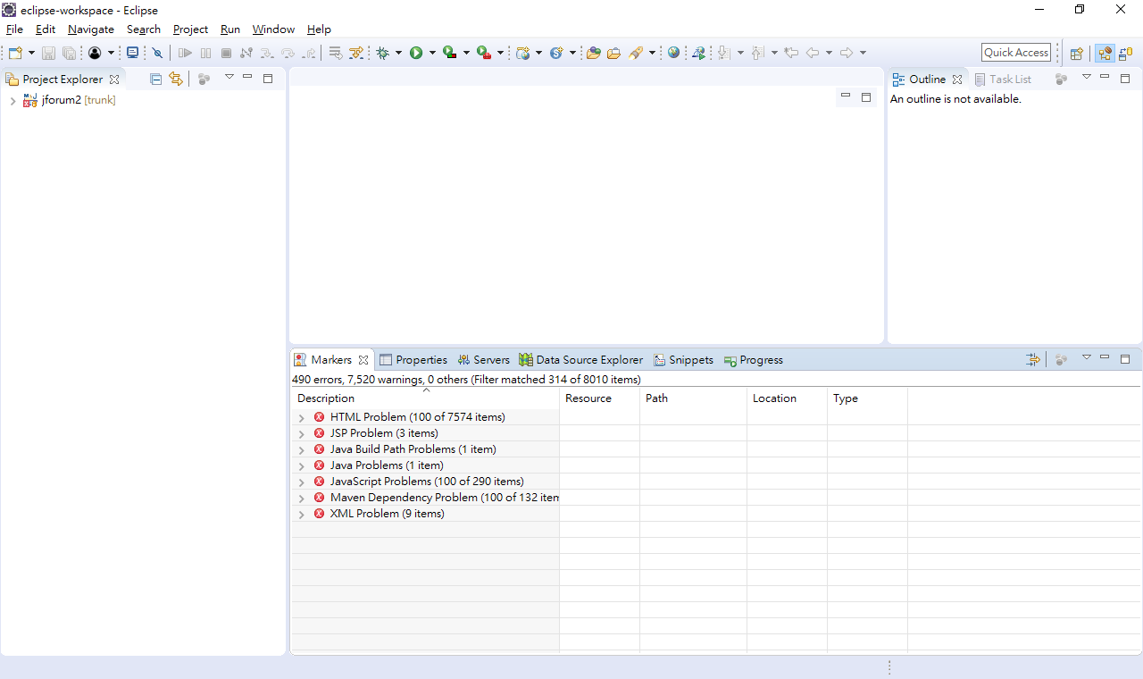

And we have some Maven Dependency Problem

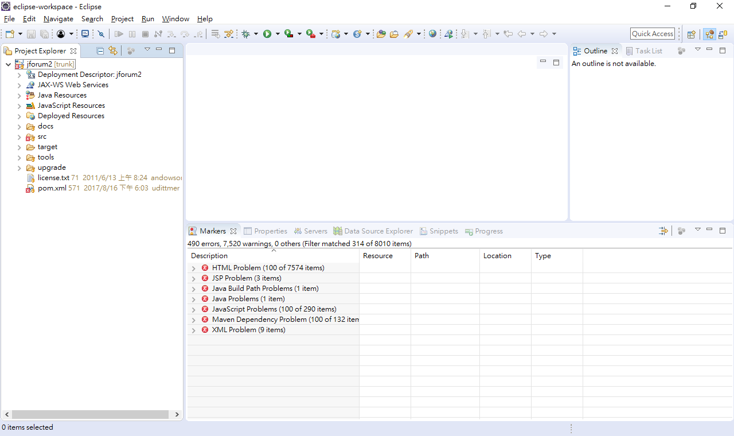
Failed to read artifact descriptor for com.jhlabs:imaging:jar:01012005

org.eclipse.aether.resolution.ArtifactDescriptorException: Failed to read artifact descriptor for com.jhlabs:imaging:jar:01012005
at org.apache.maven.repository.internal.DefaultArtifactDescriptorReader.loadPom(DefaultArtifactDescriptorReader.java:282)
at org.apache.maven.repository.internal.DefaultArtifactDescriptorReader.readArtifactDescriptor(DefaultArtifactDescriptorReader.java:198)
at org.eclipse.aether.internal.impl.DefaultDependencyCollector.resolveCachedArtifactDescriptor(DefaultDependencyCollector.java:535)
at org.eclipse.aether.internal.impl.DefaultDependencyCollector.getArtifactDescriptorResult(DefaultDependencyCollector.java:519)
at org.eclipse.aether.internal.impl.DefaultDependencyCollector.processDependency(DefaultDependencyCollector.java:409)
at org.eclipse.aether.internal.impl.DefaultDependencyCollector.processDependency(DefaultDependencyCollector.java:363)
at org.eclipse.aether.internal.impl.DefaultDependencyCollector.process(DefaultDependencyCollector.java:351)
at org.eclipse.aether.internal.impl.DefaultDependencyCollector.doRecurse(DefaultDependencyCollector.java:504)
at org.eclipse.aether.internal.impl.DefaultDependencyCollector.processDependency(DefaultDependencyCollector.java:458)
at org.eclipse.aether.internal.impl.DefaultDependencyCollector.processDependency(DefaultDependencyCollector.java:363)
at org.eclipse.aether.internal.impl.DefaultDependencyCollector.process(DefaultDependencyCollector.java:351)
at org.eclipse.aether.internal.impl.DefaultDependencyCollector.collectDependencies(DefaultDependencyCollector.java:254)
at org.eclipse.aether.internal.impl.DefaultRepositorySystem.collectDependencies(DefaultRepositorySystem.java:316)
at org.apache.maven.project.DefaultProjectDependenciesResolver.resolve(DefaultProjectDependenciesResolver.java:172)
at org.apache.maven.project.DefaultProjectBuilder.resolveDependencies(DefaultProjectBuilder.java:215)
at org.apache.maven.project.DefaultProjectBuilder.build(DefaultProjectBuilder.java:188)
at org.apache.maven.project.DefaultProjectBuilder.build(DefaultProjectBuilder.java:119)
at org.eclipse.m2e.core.internal.embedder.MavenImpl.readMavenProject(MavenImpl.java:636)
at org.eclipse.m2e.core.internal.project.registry.DefaultMavenDependencyResolver.resolveProjectDependencies(DefaultMavenDependencyResolver.java:63)
at org.eclipse.m2e.core.internal.project.registry.ProjectRegistryManager.refreshPhase2(ProjectRegistryManager.java:530)
at org.eclipse.m2e.core.internal.project.registry.ProjectRegistryManager$3.call(ProjectRegistryManager.java:492)
at org.eclipse.m2e.core.internal.project.registry.ProjectRegistryManager$3.call(ProjectRegistryManager.java:1)
at org.eclipse.m2e.core.internal.embedder.MavenExecutionContext.executeBare(MavenExecutionContext.java:177)
at org.eclipse.m2e.core.internal.embedder.MavenExecutionContext.execute(MavenExecutionContext.java:151)
at org.eclipse.m2e.core.internal.project.registry.ProjectRegistryManager.refresh(ProjectRegistryManager.java:496)
at org.eclipse.m2e.core.internal.project.registry.ProjectRegistryManager.refresh(ProjectRegistryManager.java:351)
at org.eclipse.m2e.core.internal.project.registry.ProjectRegistryRefreshJob$1$1.call(ProjectRegistryRefreshJob.java:89)
at org.eclipse.m2e.core.internal.project.registry.ProjectRegistryRefreshJob$1$1.call(ProjectRegistryRefreshJob.java:1)
at org.eclipse.m2e.core.internal.embedder.MavenExecutionContext.executeBare(MavenExecutionContext.java:177)
at org.eclipse.m2e.core.internal.embedder.MavenExecutionContext.execute(MavenExecutionContext.java:151)
at org.eclipse.m2e.core.internal.embedder.MavenExecutionContext.execute(MavenExecutionContext.java:99)
at org.eclipse.m2e.core.internal.embedder.MavenImpl.execute(MavenImpl.java:1351)
at org.eclipse.m2e.core.internal.project.registry.ProjectRegistryRefreshJob$1.call(ProjectRegistryRefreshJob.java:87)
at org.eclipse.m2e.core.internal.project.registry.ProjectRegistryRefreshJob$1.call(ProjectRegistryRefreshJob.java:1)
at org.eclipse.m2e.core.internal.embedder.MavenExecutionContext.executeBare(MavenExecutionContext.java:177)
at org.eclipse.m2e.core.internal.embedder.MavenExecutionContext.execute(MavenExecutionContext.java:151)
at org.eclipse.m2e.core.internal.embedder.MavenExecutionContext.execute(MavenExecutionContext.java:99)
at org.eclipse.m2e.core.internal.embedder.MavenImpl.execute(MavenImpl.java:1355)
at org.eclipse.m2e.core.internal.project.registry.ProjectRegistryRefreshJob.run(ProjectRegistryRefreshJob.java:81)
at org.eclipse.core.internal.jobs.Worker.run(Worker.java:56)
Caused by: org.eclipse.aether.resolution.ArtifactResolutionException: Failure to transfer com.jhlabs:imaging:pom:01012005 from http://forge.octo.com/archiva/repository/3rd-party was cached in the local repository, resolution will not be reattempted until the update interval of 3rd-party has elapsed or updates are forced. Original error: Could not transfer artifact com.jhlabs:imaging:pom:01012005 from/to 3rd-party (http://forge.octo.com/archiva/repository/3rd-party): forge.octo.com
at org.eclipse.aether.internal.impl.DefaultArtifactResolver.resolve(DefaultArtifactResolver.java:444)
at org.eclipse.aether.internal.impl.DefaultArtifactResolver.resolveArtifacts(DefaultArtifactResolver.java:246)
at org.eclipse.aether.internal.impl.DefaultArtifactResolver.resolveArtifact(DefaultArtifactResolver.java:223)
at org.apache.maven.repository.internal.DefaultArtifactDescriptorReader.loadPom(DefaultArtifactDescriptorReader.java:267)
... 39 more
Caused by: org.eclipse.aether.transfer.ArtifactTransferException: Failure to transfer com.jhlabs:imaging:pom:01012005 from http://forge.octo.com/archiva/repository/3rd-party was cached in the local repository, resolution will not be reattempted until the update interval of 3rd-party has elapsed or updates are forced. Original error: Could not transfer artifact com.jhlabs:imaging:pom:01012005 from/to 3rd-party (http://forge.octo.com/archiva/repository/3rd-party): forge.octo.com
at org.eclipse.aether.internal.impl.DefaultUpdateCheckManager.newException(DefaultUpdateCheckManager.java:238)
at org.eclipse.aether.internal.impl.DefaultUpdateCheckManager.checkArtifact(DefaultUpdateCheckManager.java:206)
at org.eclipse.aether.internal.impl.DefaultArtifactResolver.gatherDownloads(DefaultArtifactResolver.java:585)
at org.eclipse.aether.internal.impl.DefaultArtifactResolver.performDownloads(DefaultArtifactResolver.java:503)
at org.eclipse.aether.internal.impl.DefaultArtifactResolver.resolve(DefaultArtifactResolver.java:421)
... 42 more

Change to the user’s .m2 repository and navigate to the com\jhlabs directory
Path: C:\Users\%username%\.m2\repository\com\jhlabs
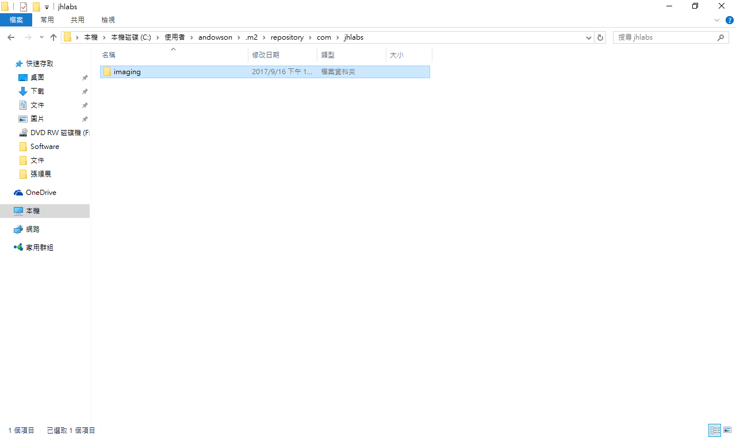
Download the imaging.zip from jforum.andowson.com and extract these files into the directory
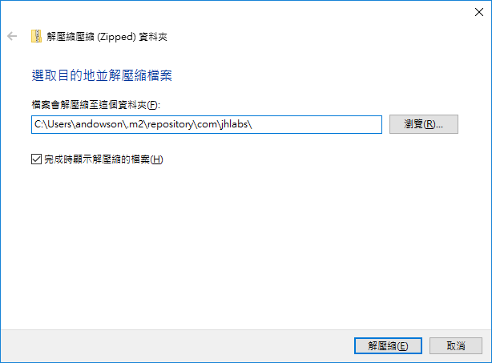
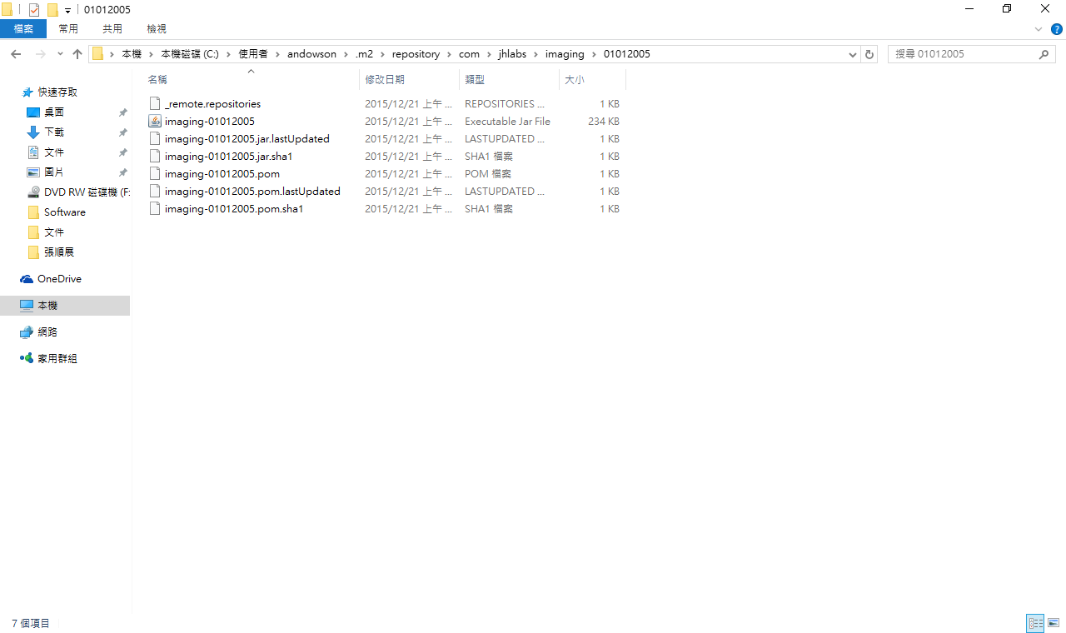
Right click on project name and run Maven > Update Project
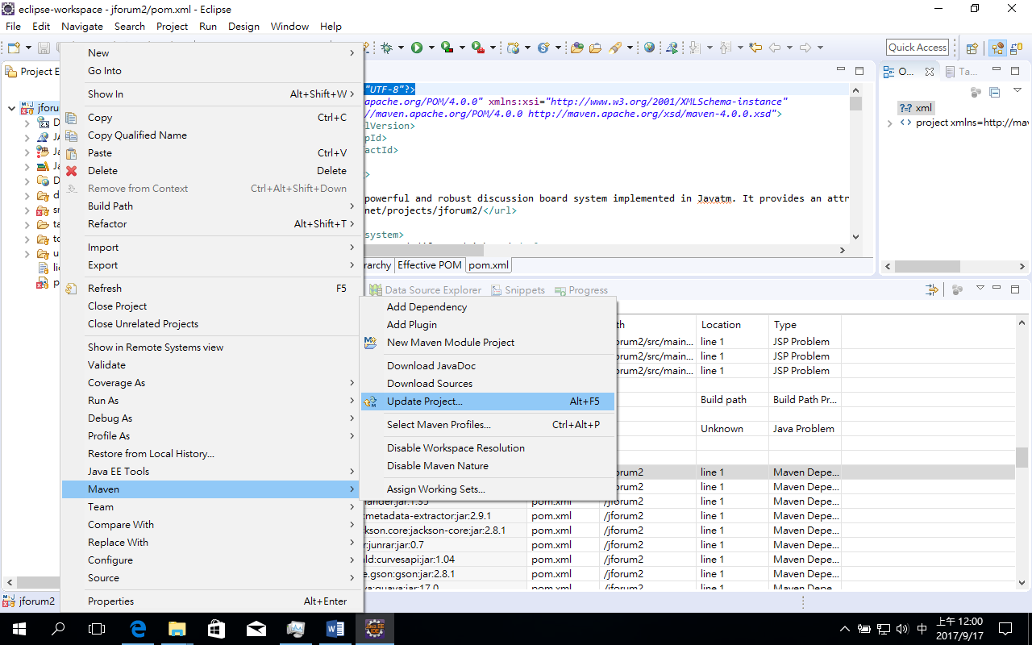
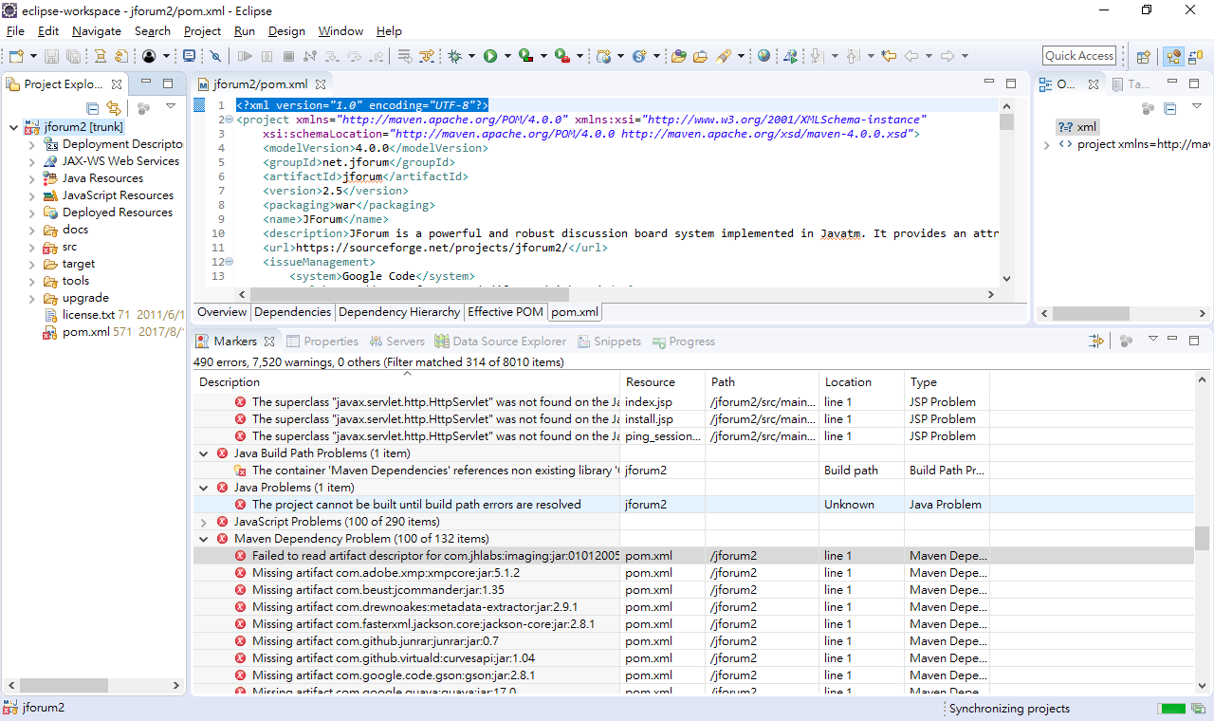
Now, the Maven dependency problem is solved.
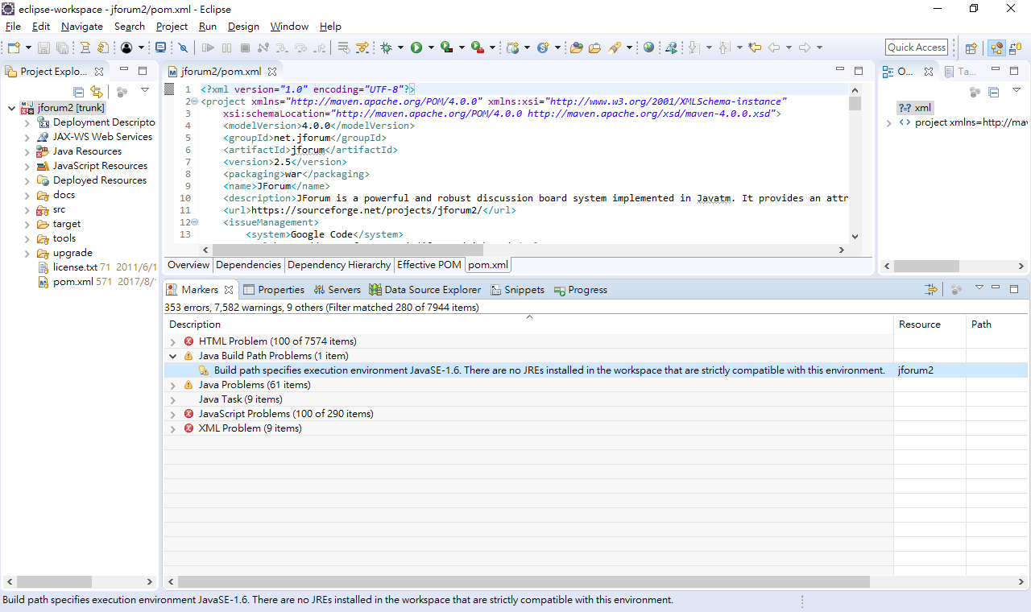

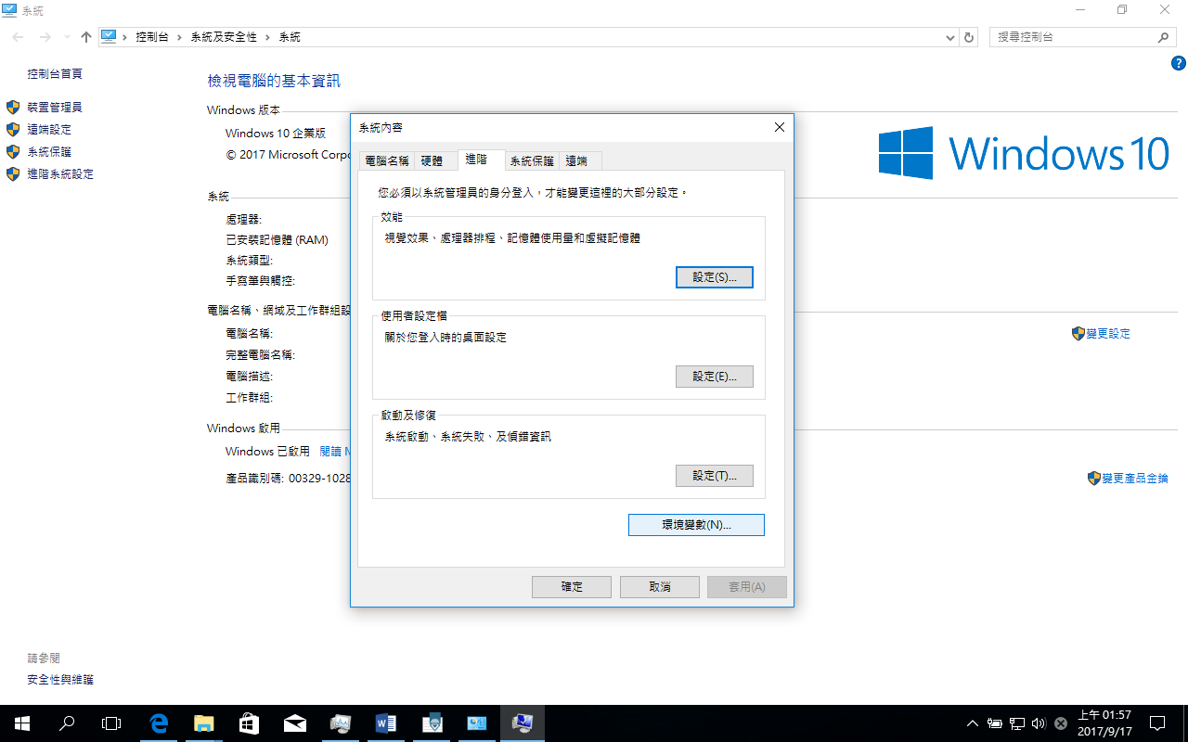
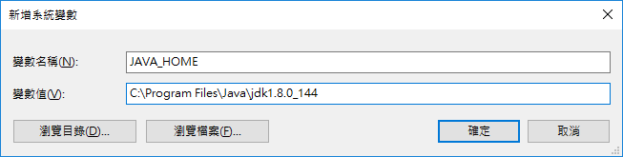
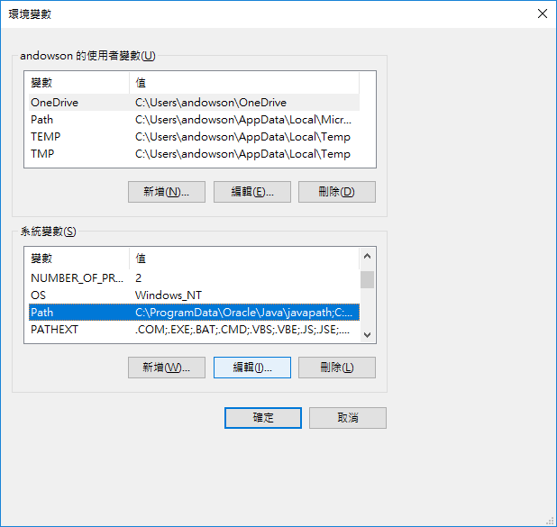
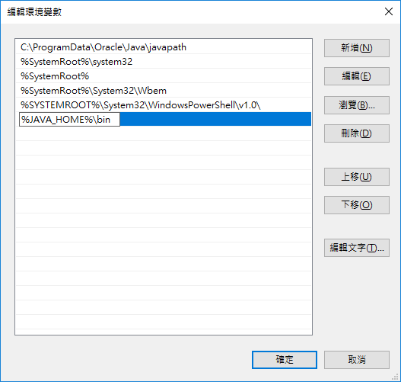
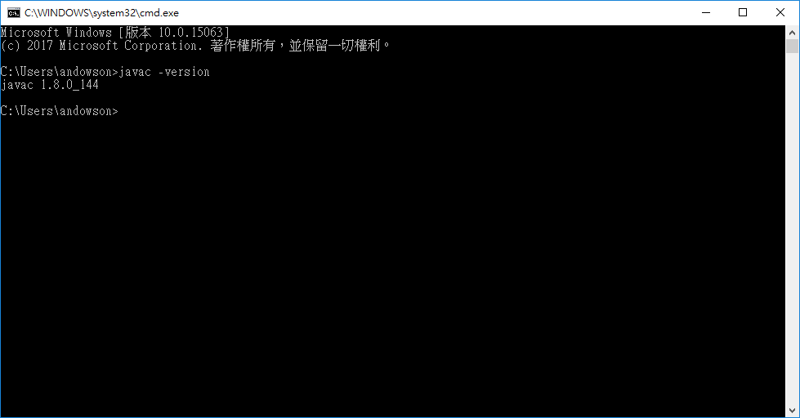

Maven Build

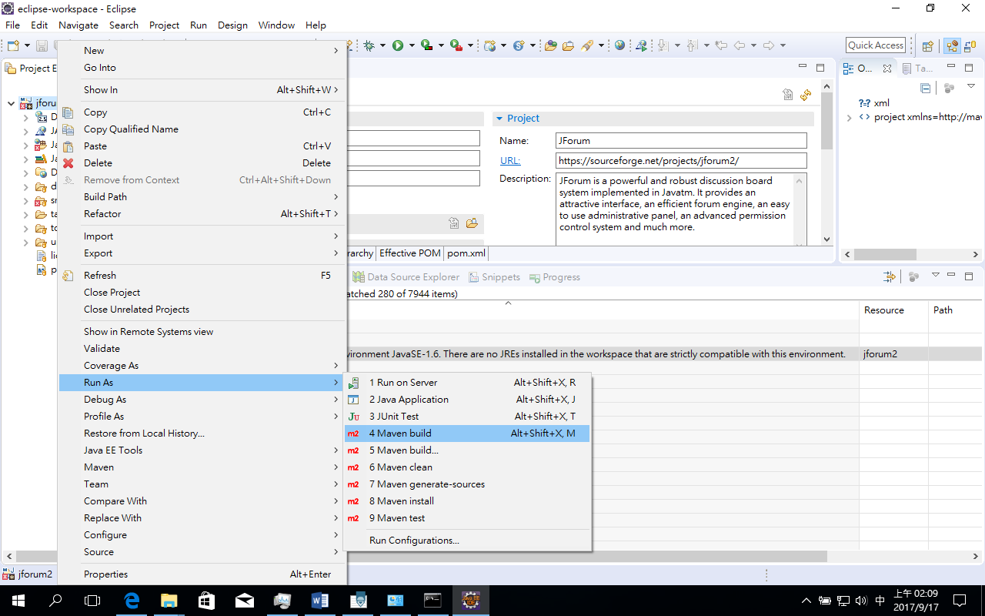

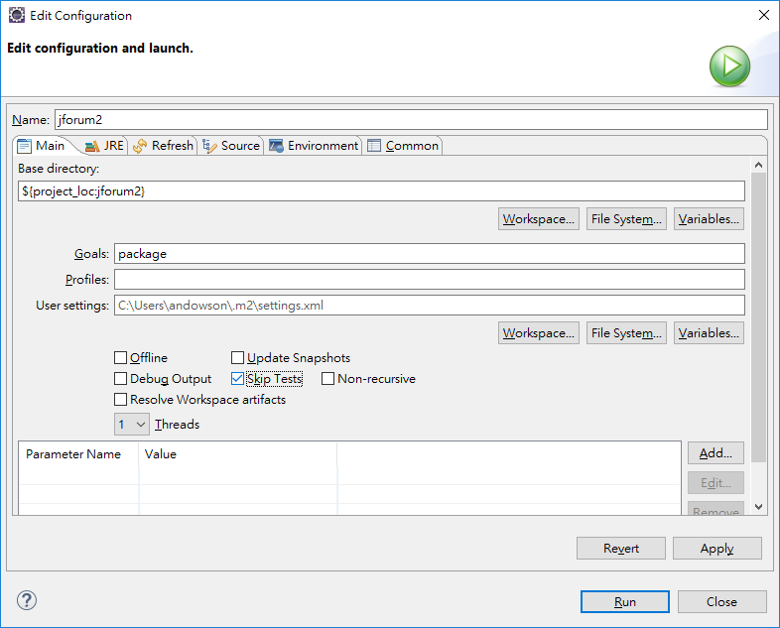
Goals: package
Check Skip Tests for now. We just want to verify that all the codes can be built in Eclipse.
Apply->Run
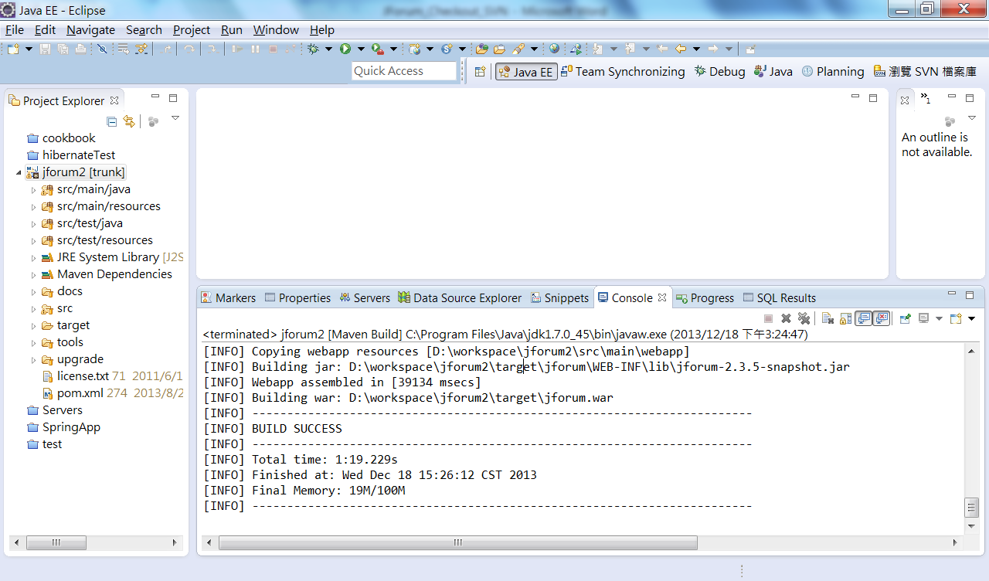
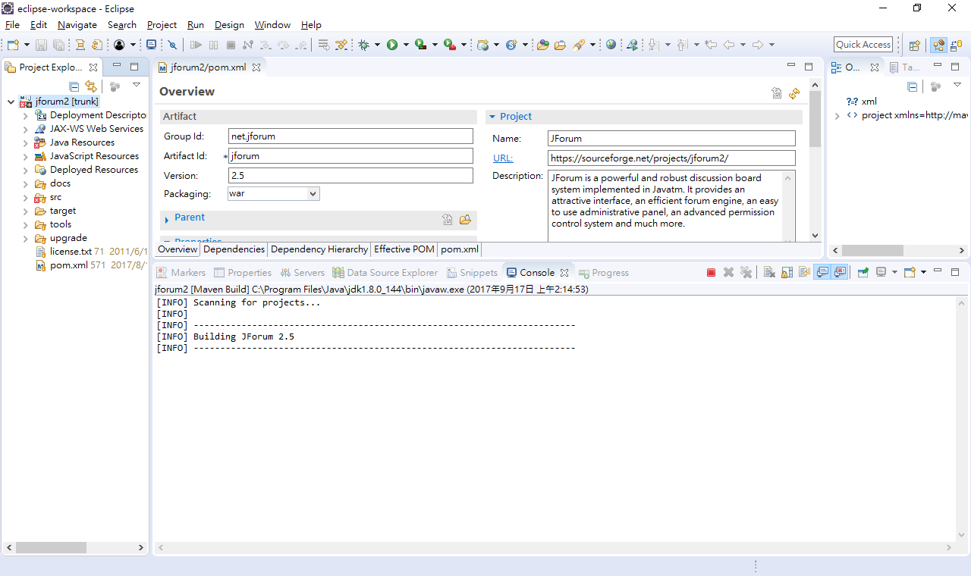
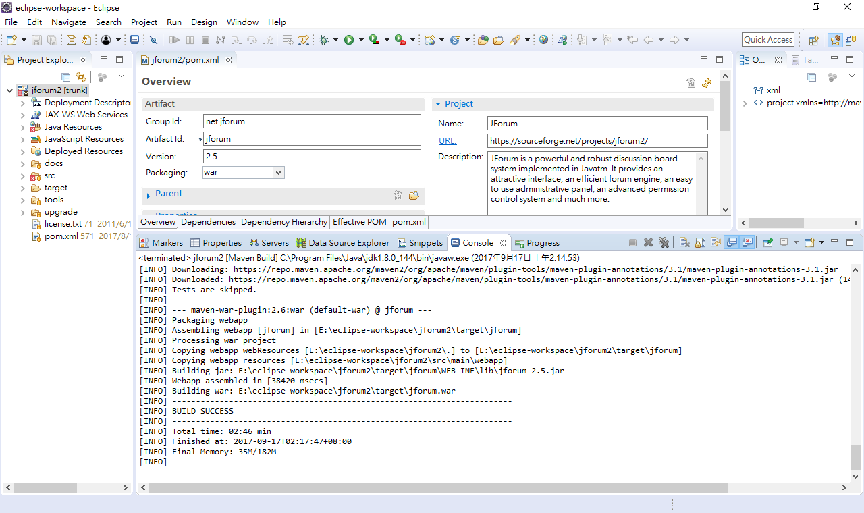
Maven clean

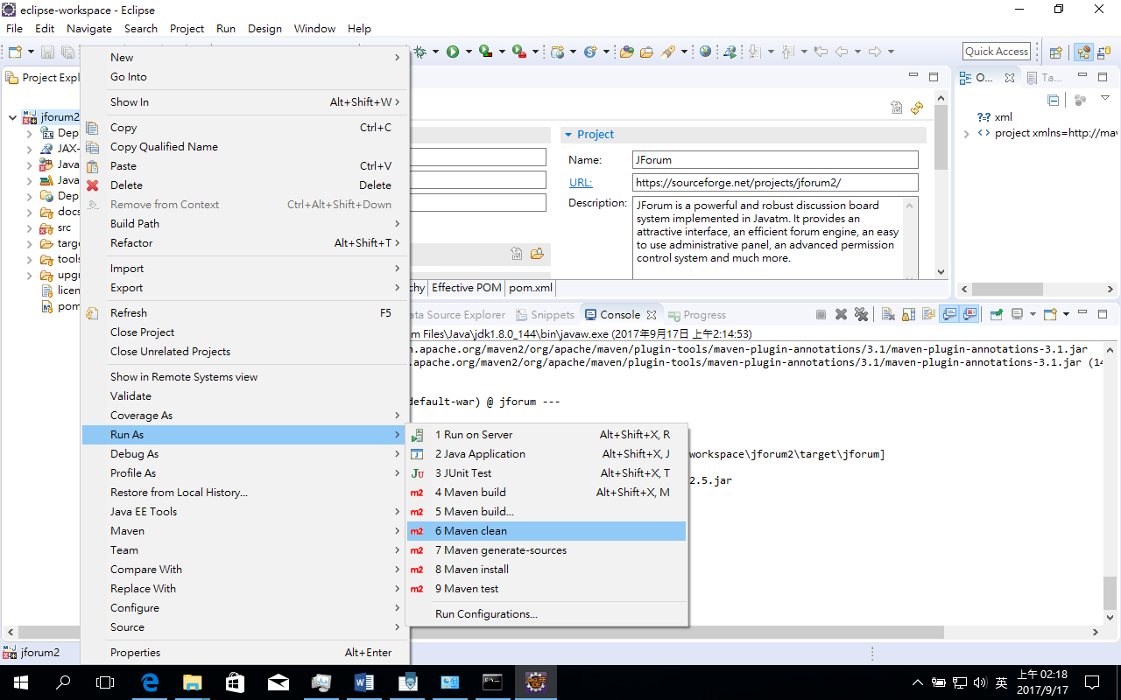

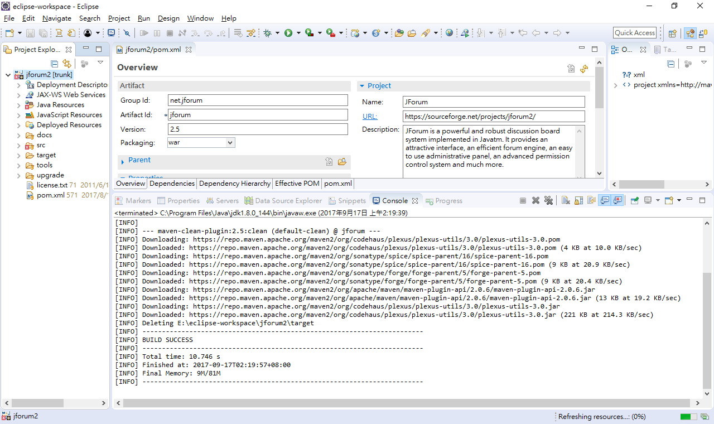
OK, now you can start to develop new programs.

