Build JForum with NetBeans IDE
Download NetBeans IDE for Java EE and Install it
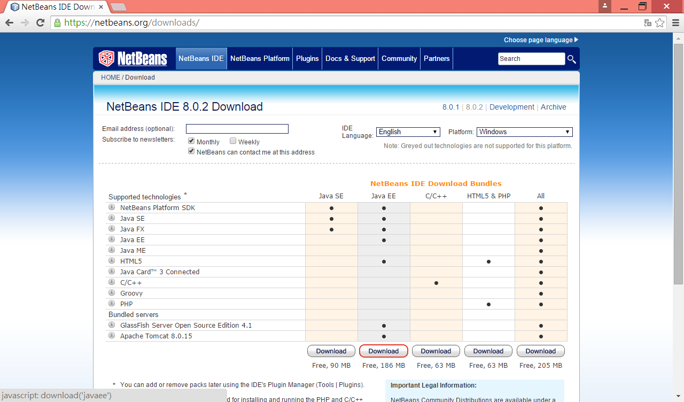

Enable Subversion from the menu Tools > Options > Team > Versioning
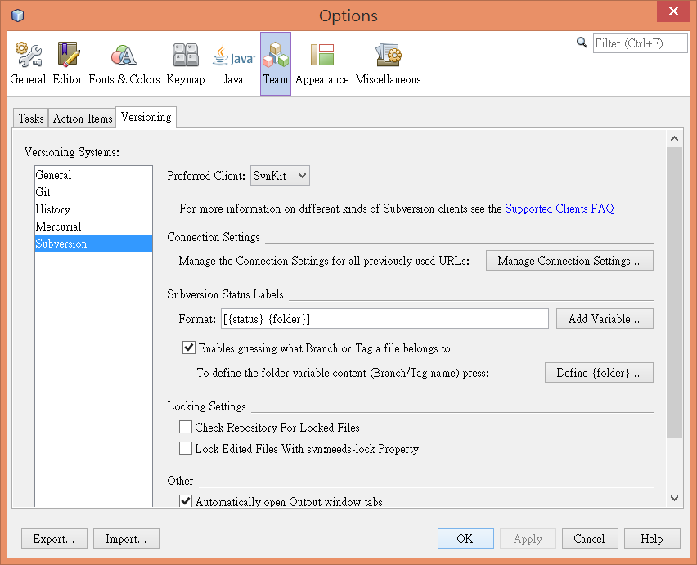
Checkout source code from the menu Team > Subversion > Checkout

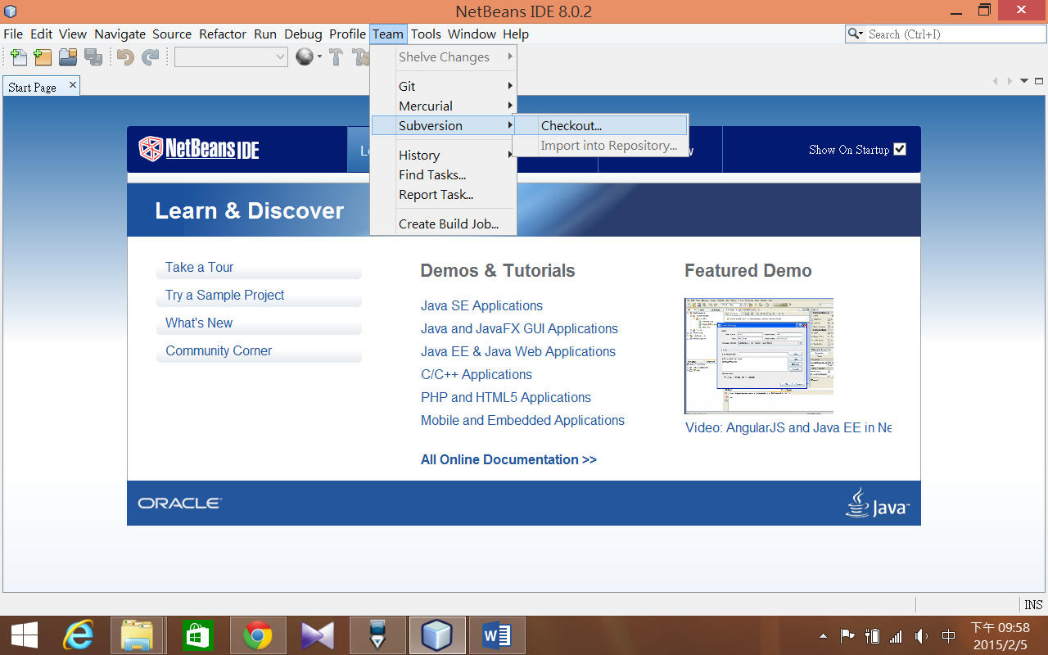

Enter Repository URL: https://jforum2.googlecode.com/svn/trunk/
User:
Password:
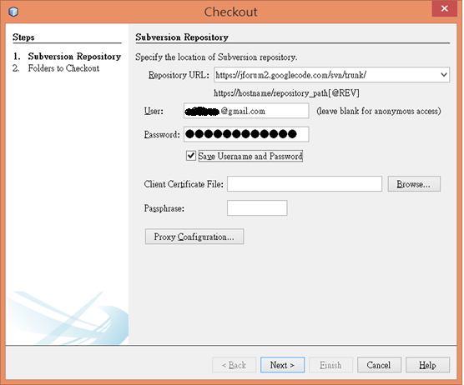
Skip “trunk” and check out only its content
Specify the local folder to checkout folders into
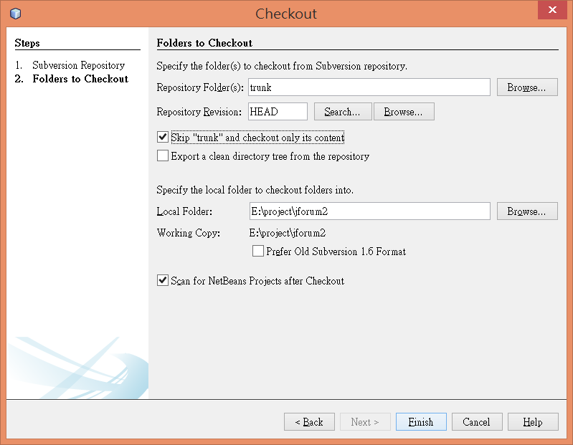
Click Open Project
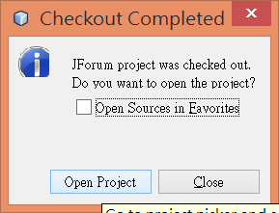
Download MySQL Community Server
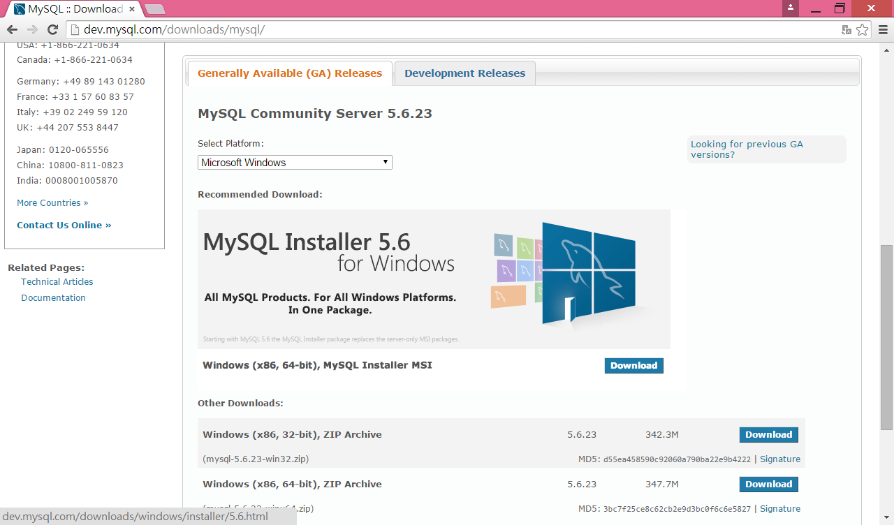
Download MySQL Installer
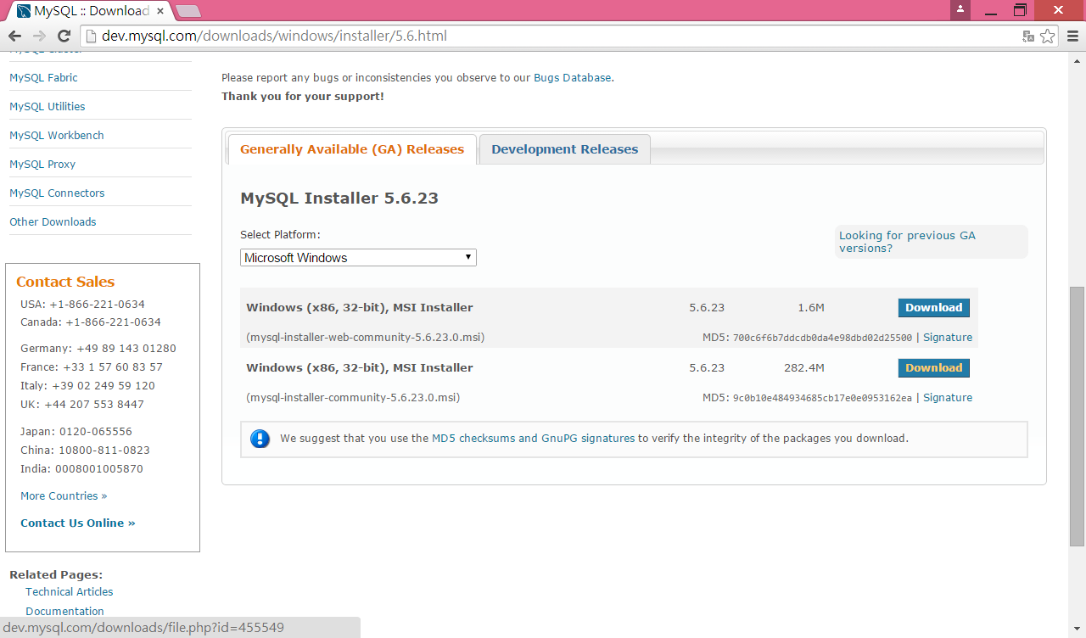
Install MySQL Server and Workbench
Set root password with root
Launch MySQL Workbench and Click the icon to create a new schema called jforum
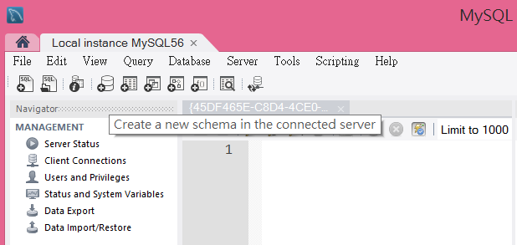
Use File > Open SQL Script to load and run the two SQL scripts:
E:\project\jforum2\src\main\config\database\mysql\mysql_db_struct.sql
E:\project\jforum2\src\main\config\database\mysql\ mysql_data_dump.sql
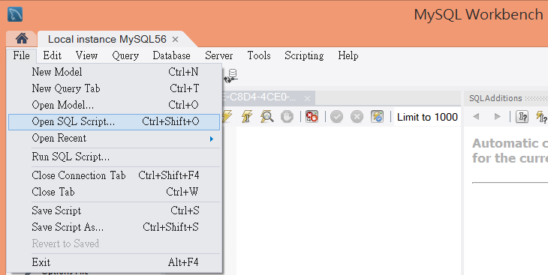
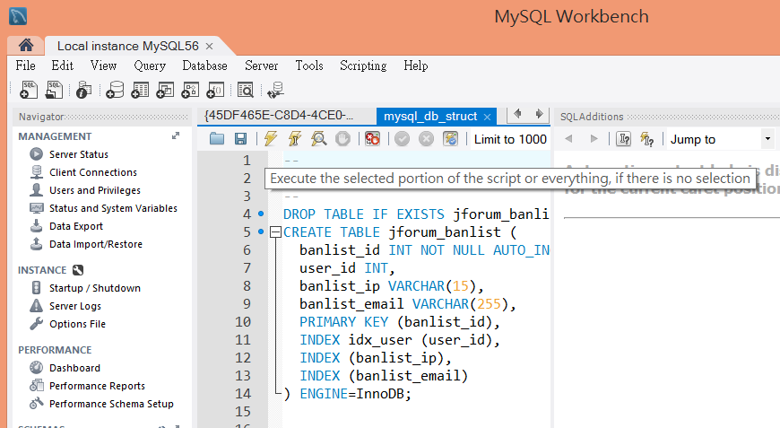
OK, go back to NetBeans IDE
Build
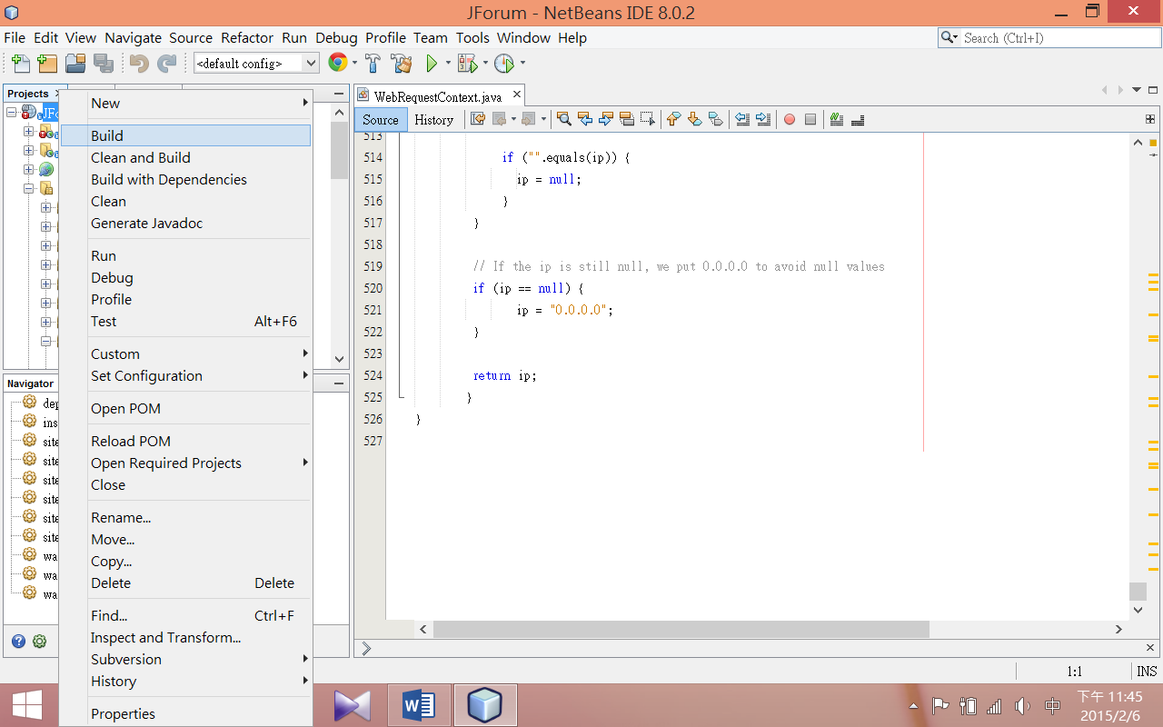
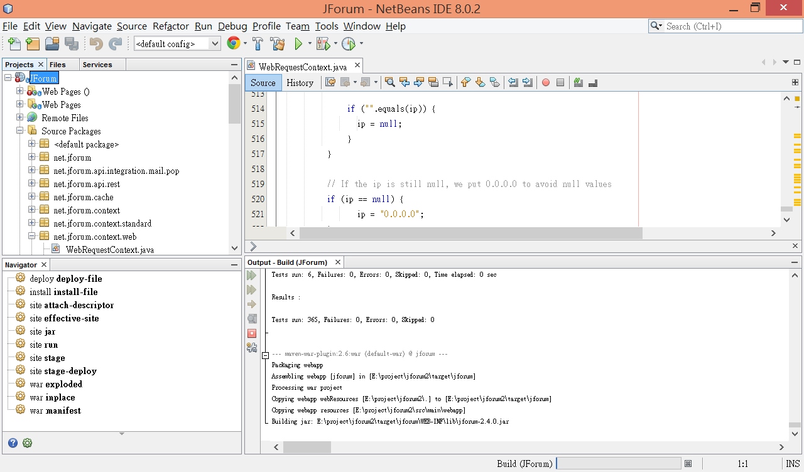
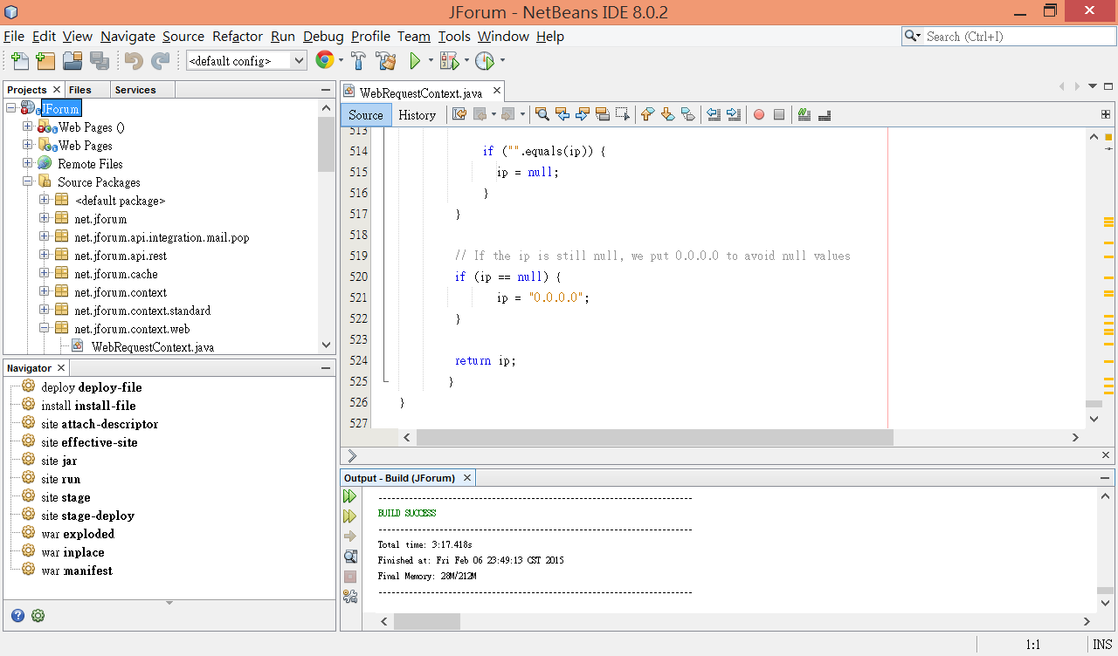
Build Success! Good Job.

